**DC Voltage Doubler Circuit**

**Introduction:**

The DC Voltage Doubler Circuit is a simple yet effective electronic circuit designed to take in a DC voltage ranging from 9V to 18V and produce an output voltage approximately double the input voltage. This project is implemented using a 555 Timer IC, diodes, and capacitors to create a **capacitor charge pump**, effectively doubling the input voltage.

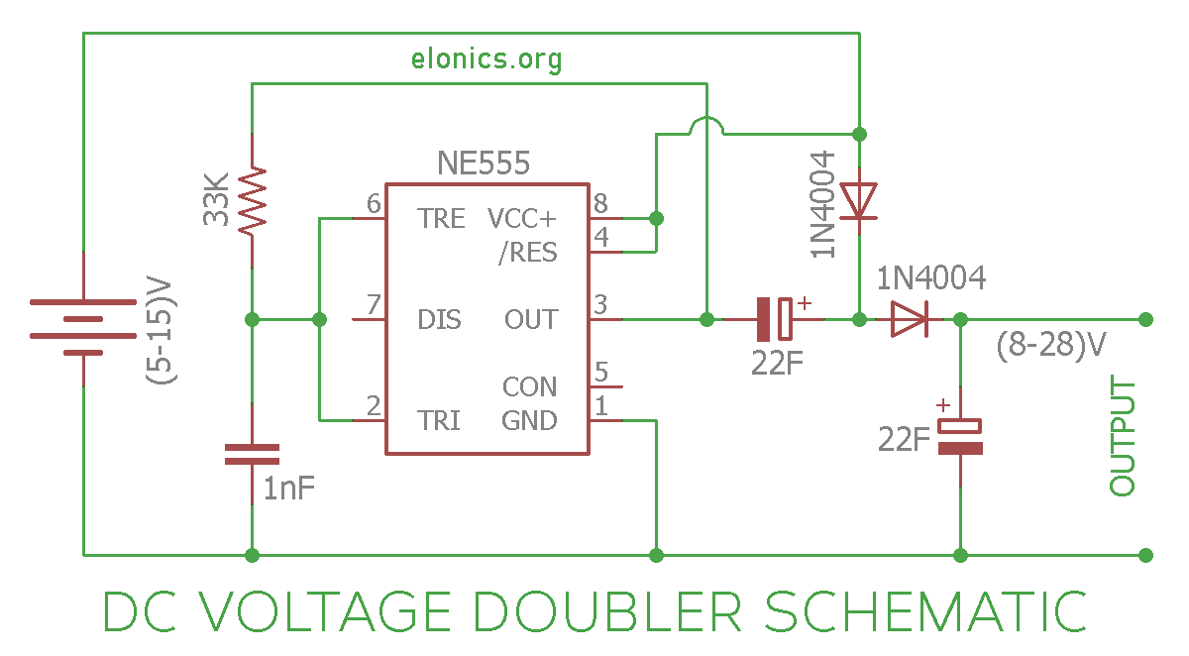

**Components Used:**

1. **555 Timer IC**
2. **Diodes:** 2 x (1N4007)
3. **Capacitors:** 2 x 22uF 50v (labeled as 105) , 1 x 0.1uF 50v
4. **33K Resistor**
5. **Breadboard**
6. **9V Power Supply**

**Circuit Explanation:**

**1. 555 Timer IC:**

* The 555 Timer IC is configured in Astable mode to generate a square wave at its output (Pin-3). This square wave alternates between positive and negative voltage continuously.

The 555 timer IC (integrated circuit) is an extremely popular and versatile **analog timer** used in a variety of electronic circuits.

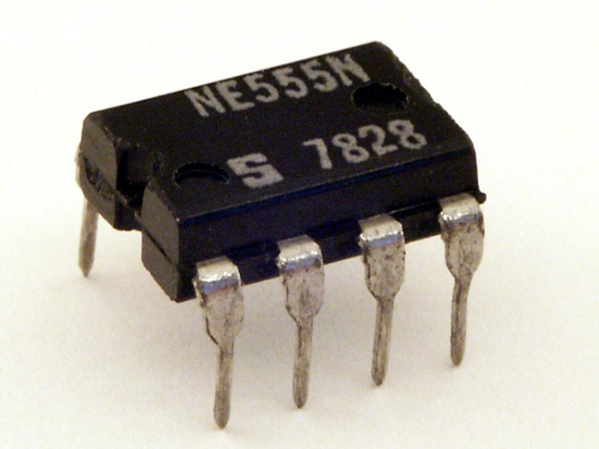

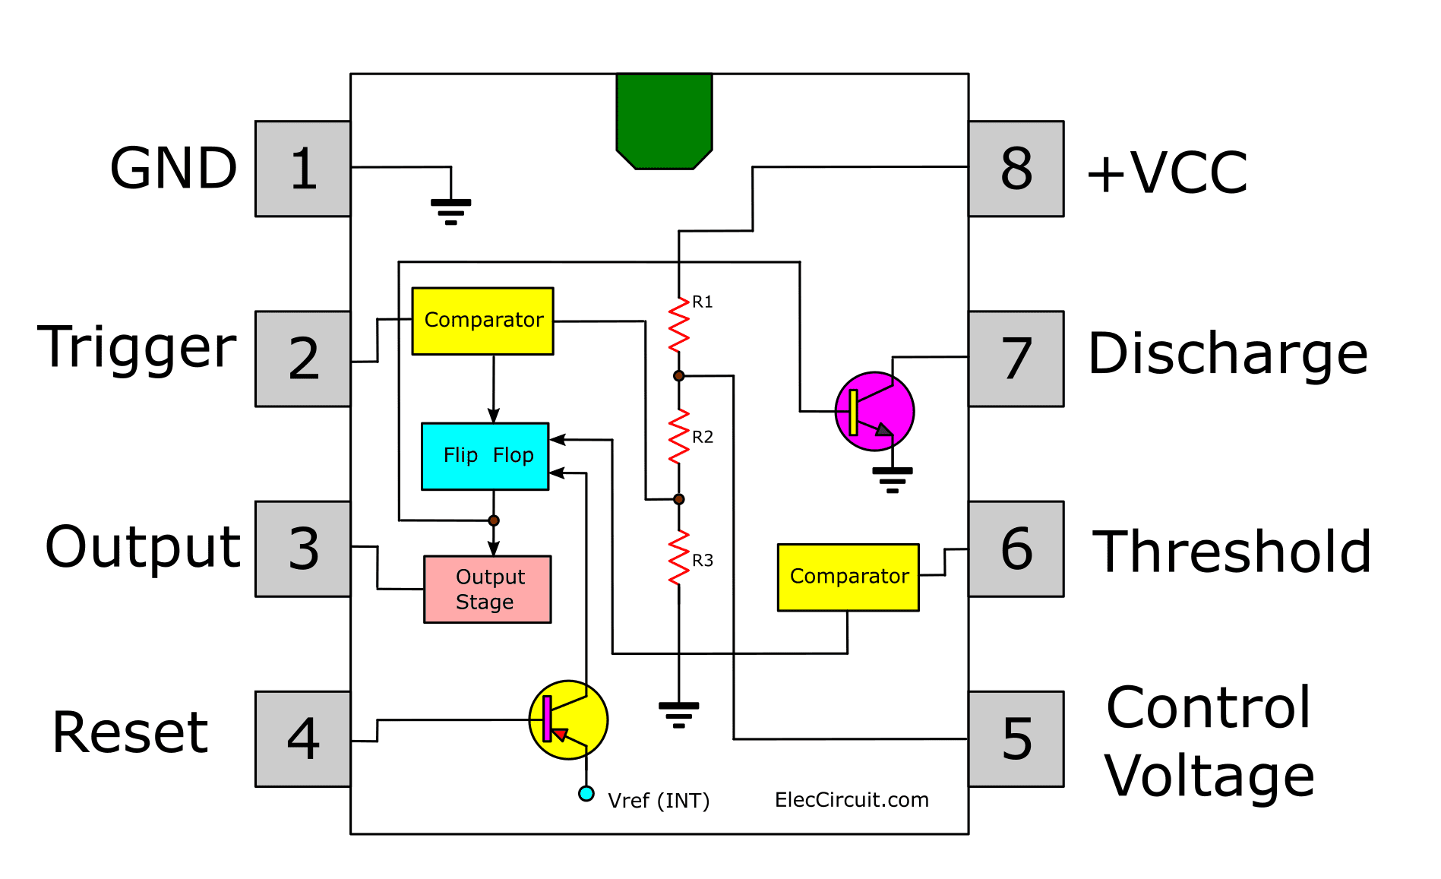

**2. Capacitor Charge Pump:**

* A 22uF capacitor is connected with its negative terminal to the output of the 555 timer IC and its positive terminal to the positive rail through a diode.
* When the 555 timer output is at 0V (negative voltage), the capacitor charges through the diode.
* The voltage across the capacitor is equal to the power supply voltage minus the forward bias voltage of the diode.
* When the 555 timer output is at a positive voltage, the voltage across the capacitor adds up with the voltage from the 555 timer output, resulting in a voltage approximately double the input voltage.

**3. Voltage Doubling Mechanism:**

* The voltage at the other end of the 22uF capacitor is equal to the voltage at the output of the 555 timer IC plus the voltage across the capacitor.
* Since both are equal to the positive voltage of the power supply, the final voltage is approximately double the input voltage.

**4. Diode Configuration:**

* Another diode is added to prevent current from flowing back to the capacitor from the output load, ensuring a unidirectional flow.
* A 22uF capacitor is added at the output to smoothen out the output.

**Conclusion:**

The implemented capacitor charge pump mechanism, using a 555 timer and diodes, allows for an efficient doubling of the input DC voltage.

**Simulation:**

